What is JobViz (v 1.0):
- JobViz is a tool Galactic Polymath developed using public data (mostly from the Bureau of Labor Statistics) for anyone 11 years of age and older to explore the true diversity of career options out there (>1k occupations).
- JobViz is a lightweight tool to scaffold career exploration by providing a browseable, searchable hierarchy of occupations, and surfacing the 7 key bits of info students want to know:
- Job definition
- Median wage
- Education needed
- 2024 employment numbers
- 2034 predicted employment
- predicted change in employment
- As a paid feature (part of GP+, Galactic Polymath’s cheap subscription for teachers), teachers can also share a “career tour” assignment.
  - There are prebuilt tours with each of our units.
  - A tour provides a set of 6-8 jobs associated with a set of lessons in a unit, along with a prebuilt assignment prompt: “Explore these jobs and explain with data which you would be most or least interested in.”
  - This tour is shareable with a link
  - We would like to design an editor functionality so that teachers with a GP+ subscription can build and share career tours.
- JobViz allows you to search for a job, surface the key stats, link to related posts on the Occupational Outlook Handbook for more details, and click a link to explore related careers in the hierarchy of jobs categories.
- As you navigate the job hierarchy, the URL changes, so you can copy a link directly to your current view.
- The goal is to open up new opportunities for students, make it easy for teachers to connect abstract classwork to real careers, and to provide a streamlined tool for students (and everyone) to gain a better overall systems understanding of the economy and how we all fit into it.

Tech Stack:
- Jobviz is built from scratch as a component of our next.js teacher portal that contains all our units at teach.galacticpolymath.com
- It’s now integrated into our teaching units and meant to offer an additional value add for our science curriculum (because it’s already career-aligned/ connected to workforce development)
- It’s styled in bootstrap (along with our entire site)

Goals for JobViz 2.0
- Overhaul for a modern, yet simple, shared design aesthetic
- Improve mobile responsiveness and accessibility
- Improved ease of use
- Improve classroom multi-functionality, e.g. light gamification.
  - We’re not currently trying to have students create profiles, so any interactivity should be stored in cache (e.g. ability to add emojis to a job in an assignment/career tour 🤩😀😐🙁😱)
- Improve speed and stability
- Add icons and visual flourishes to make it exciting and attractive, but not garish

Design considerations:
- Our brand is innovative, interdisciplinary, and trend-setting (ahead of the curve). Straight from the research lab into your classroom. But in an exciting, animating way; not intimidating.
- We want to match the overall design of the Squarespace marketing website, which was developed by professional designers.

Example Squarespace site layouts (galacticpolymath.com):
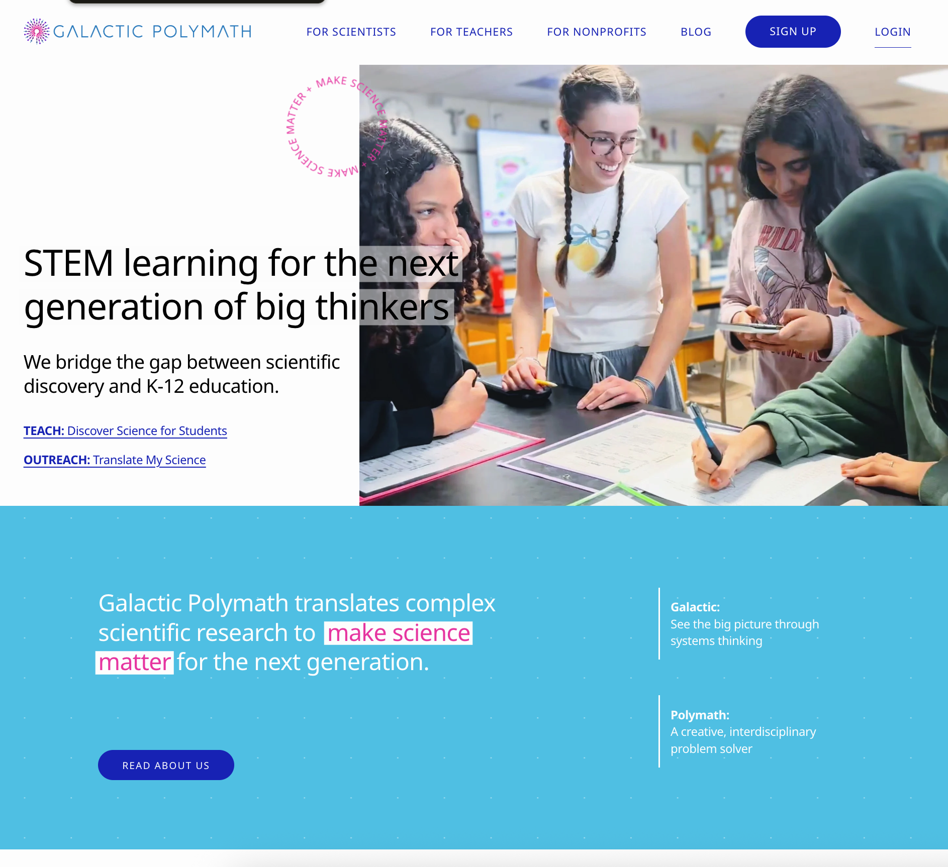

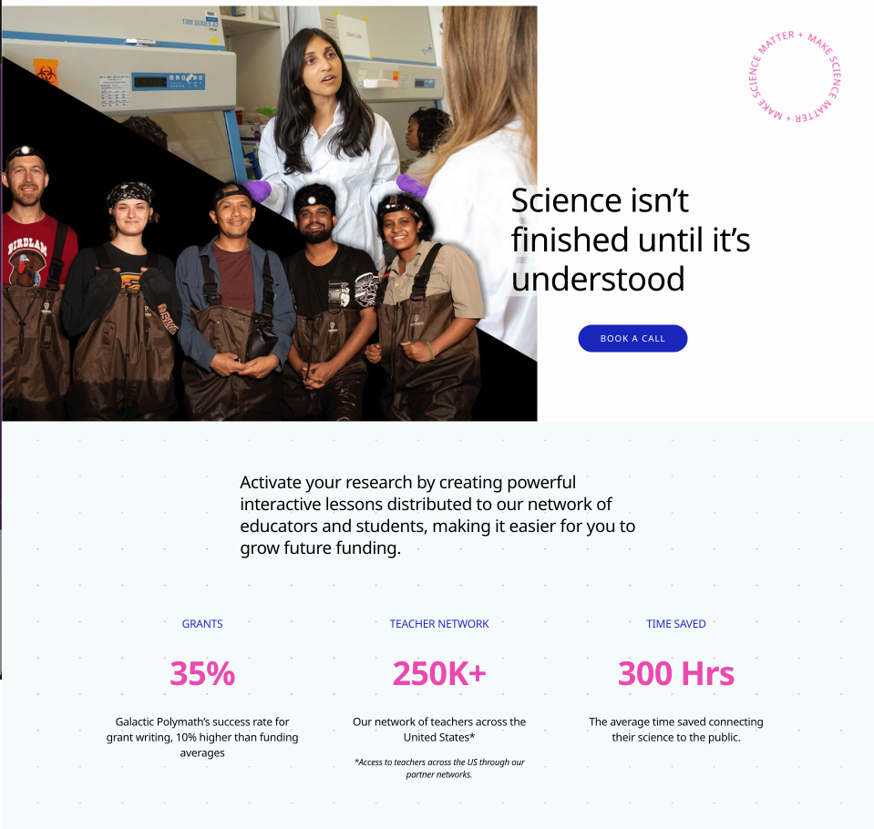

Main Palette:
GP Hydro Blue | #2C83C3 | 44,131,195
GP Lightning Purple | #6C2D82 | 108,45,130
GP Fuchsia | #ff3DAC | 255,61,172
GP Atomic Blue | #6812D1 | 104,18,209
GP Burst Purple | #cb1f83 | 203,31,142
GP Galactic Black | #363636 | 54,54,54
GP Sparkle White | #f0f4ff | 240,244,255
GP Plus Blue (only for GP+ views/ SaaS products) | #1826bc | 24, 38, 188
GP “Free Tier” Blue | #00aceb | 0, 172, 235

Primary Font: Noto Sans Light

Key functionality:
For Free users, GP+ users, and users who aren’t logged in (e.g. students)
- Search for jobs
- Browse through 4 levels of categories to surface the key stats mentioned above
  - Category cards should be easily distinguishable from job-level cards and should list how many jobs they contain, in addition to showing an icon for that job category.
  - Job-level cards (e.g. level 3 or 4, depending on how many levels of categories the BLS has given the particular occupation) should be distinguished clearly (possibly by being “filled” with some subtle gradient or distinct effect).
    - Possibly the job level-cards should have “stacked icons” like the category icon with a smaller icon nested in it that is pertinent to the particular job. Maybe something like this:
      - 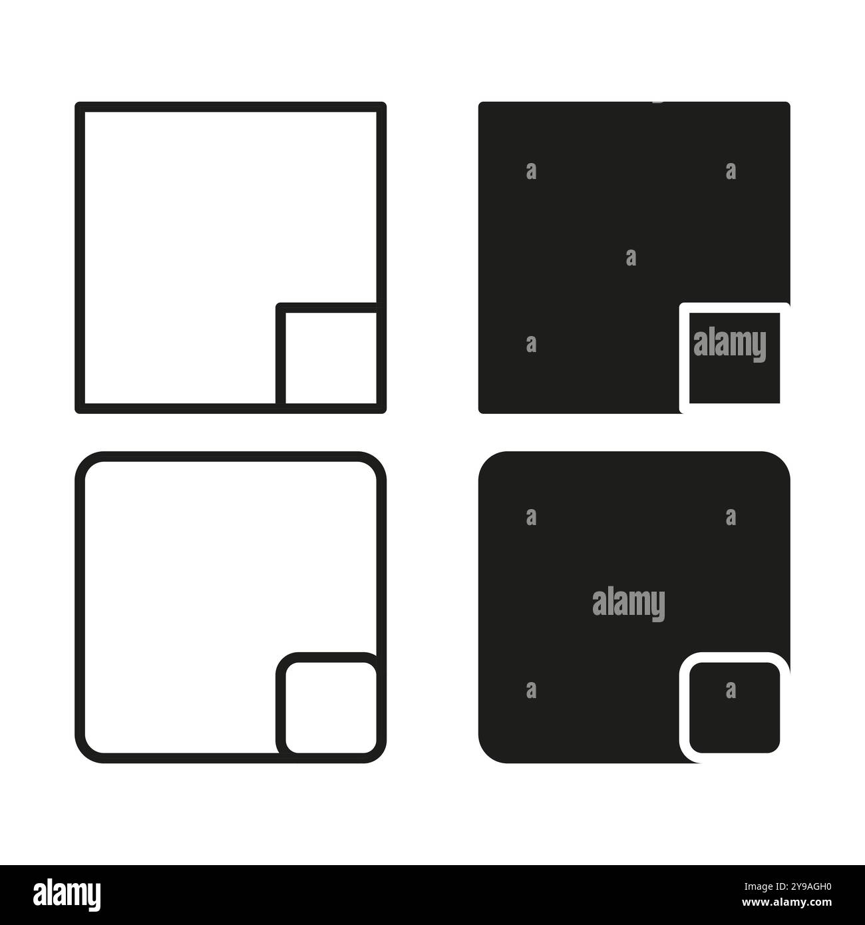
    - Clicking a job card should open a modal that compactly shows all key information on a mobile device and looks equally good on larger screens.
  - Ideally, everything is accessible, mobile responsive, and up to industry best practice design standards.
- If anyone gets a link to an “assignment”, i.e. a URL like this (https://dev.galacticpolymath.com/jobviz?socCodes=15-2051%2C15-2041%2C43-9111%2C15-1221%2C15-1242%2C15-2031%2C19-1023%2C19-4021&unitName=Data+Streams) with soc_codes and assignment parameters, they should be able to view it. This is a GP+ feature (like a Gift article for the NY Times) that is shareable.
- Assignment/Career tour functionality:
  - A persistent banner shows up with a very vertically concise assignment e.g. “Look at these jobs and tell me which you would like to do using data.”, and 6-8 jobs associated with the assignment. The jobs are listed with their little respective icons.
  - On wide screens, perhaps the assignment is on side panel docked to the side
  - On mobile, it should become very vertically tight to leave as much space as possible. Maybe the assignment text should be collapsible and the career links should be in a carousel so you’re taking up like 2-3 lines at the top of the screen max).
  - When params are present (e.g. user visits an assignment link), add an emoji toggler to the job detail modal with the prompt: Rate this job. The emojis should be (e.g. ability to add emojis to a job in an assignment/career tour 🤩😀😐🙁😱), with helper text that is 5-Love, 4-Like, 3-Meh, 2-Dislike, 1-Nope.
    - The ratings for jobs should show up in the assignment banner after the job title once selected after they’ve clicked the link, opened the modal, and rated it. Placeholder should be ❓
For GP+ Users who are logged in:
- Background is visually coded somehow that they’re seeing a GP+ premium view. (e.g. usage of GP Plus Blue color and/or the GP+ gradient shown in the Plus logos here:
- 

